Day 3 - 23rd May 2025

Day 3 - 113312696- Aditya Shubham

Task 1

What is cloud ?

Cloud is a remote server that store and deliver data, applications, and other computing resources over the internet

Advantages:

This offers numerous advantages like cost savings, enhance security, online storage and accessing the data’s from anywhere, flexibility, it will easy to collaborate with everyone, Disaster Recovery, prevention of data loss

u can find password here

C:\Users\Administrator\.jenkins\secrets\initialAdminPassword

**Jenkins**

https://docs.google.com/document/d/1fbPxQd9Xq_vLTTV800q9T4es222JmaU3QSXPVClQS5s/edit?tab=t.0#heading=h.75dqi6kl9neu

Jenkins intsall —- Done

Tomcat setup — Done

Git setup — Done

Maven Setup — Done

Configuration –Done - JENKINS_HOME" environment variable

Management –Done

Setup Build Jobs — Done

installing Jenkins > = **http://localhost:8081**

installing Tomcat >= **http://localhost:8080**

Downloading Apache Maven 3.9.9

Manage jenkins > tools > add maven with path of maven

In jenkins > plugins > maven integration plugin

> plugins > xunit plugin

Create new item > free style project

**Method 1**

In build steps > execute windows batch command

**Command**

java filename.java

java filename

Or

java filename.java

java filename.java

**Method 2**

Source code management

Git > url repository of git

In branch > give which branch the file name have

**Method 3**

In general > advance > use custom workspace

Copy path in your computer where the file there

After creating new items > click build play symbol

**MongoDB**

MongoDb Installation link

<https://www.mongodb.com/try/download/community>

MongoDb installation steps link

<https://www.mongodb.com/docs/manual/tutorial/install-mongodb-on-windows/>

this is also MongoDb link any one you can follow..

<https://www.geeksforgeeks.org/how-to-install-mongodb-on-windows/>

Mongosh installation steps link

<https://www.mongodb.com/docs/mongodb-shell/install/>

Setting the path..

Env path

C:\Program Files\MongoDB\Server\7.0\bin

C:\Program Files\MongoDB\mongosh\mongosh-2.2.12-win32-x64\bin

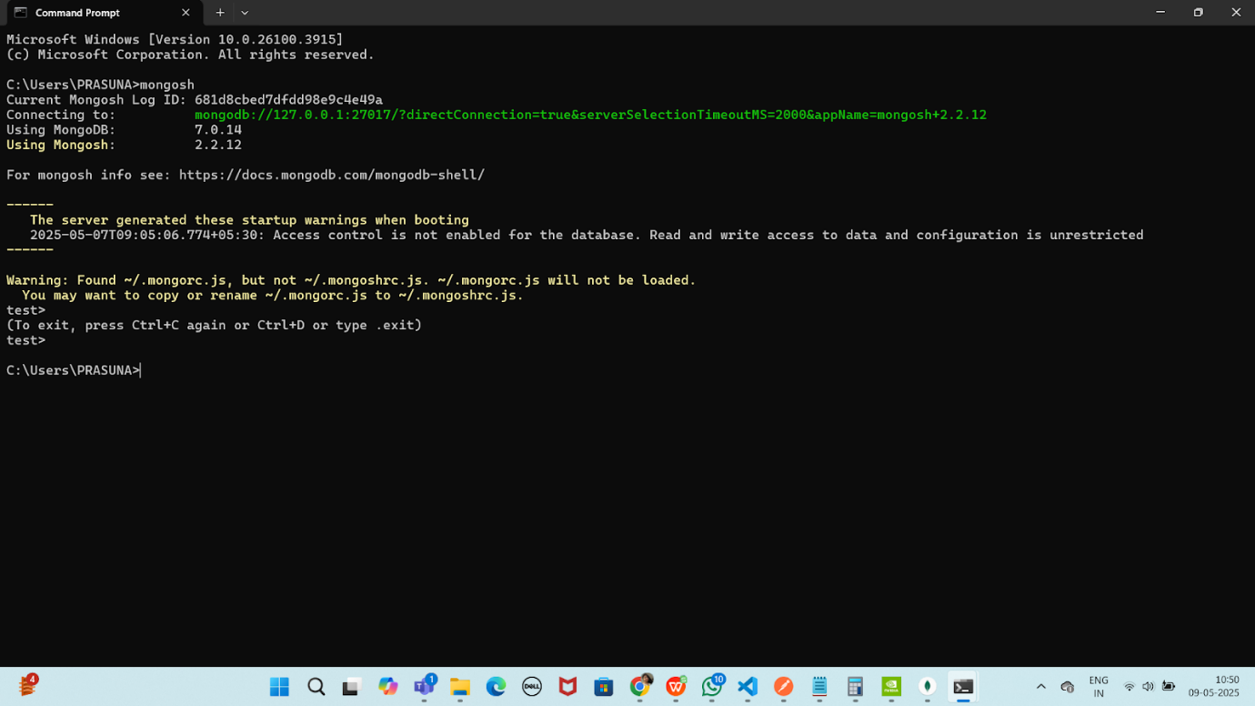

mongo db compass

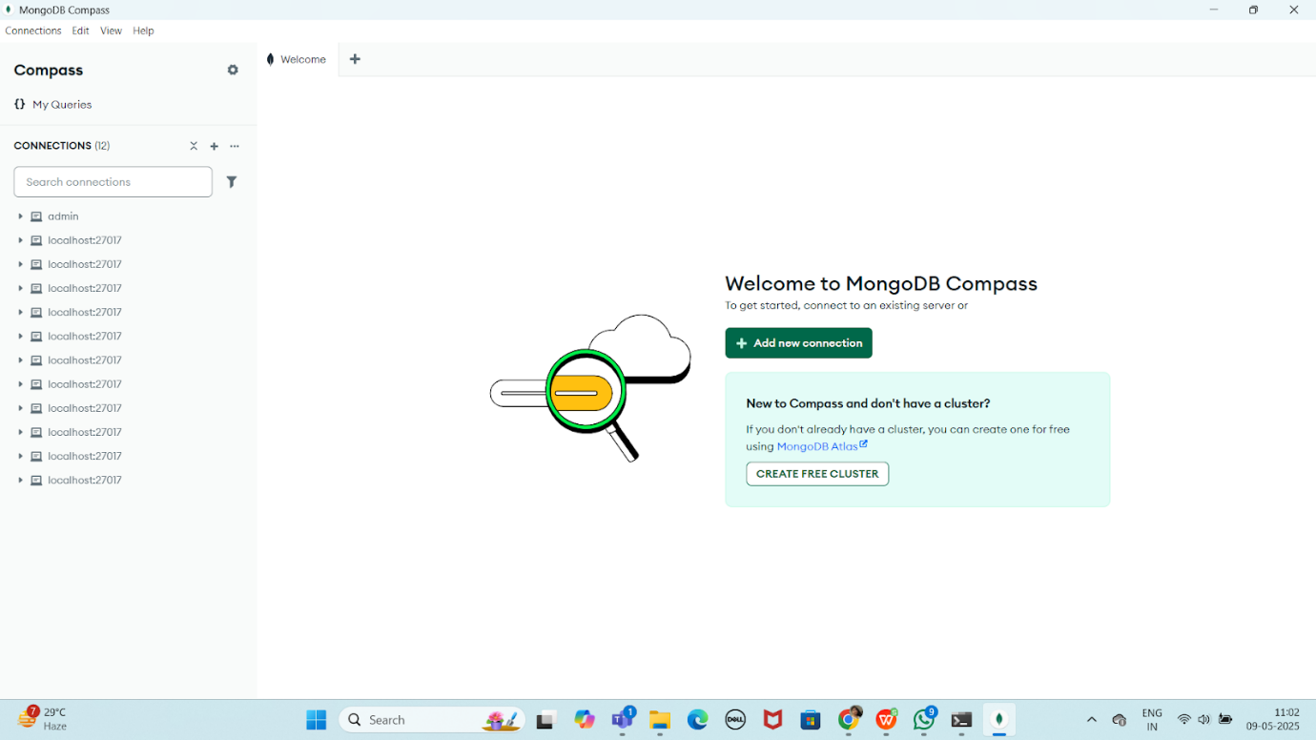

Make sure 2 cmd s are open

1. Cmd - mongod
2. Cmd - mongosh